Kamran Gul
CMS: 023-25-0161
CS AI (C)
Lab # 2

Task 1:
Write and run a program that performs the following steps:
• Create variable pi and radius r of related data type.
• Assign values to above variables.
• Calculating the circumference using the formula: C = 2*pi*r.
• Displaying the circumference C.
Solution:
#include <iostream>
using namespace std;
int main(){
float pi = 3.14;
float r = 2.3;
float C = 2*pi*r;
cout<<"The circumference is: "<<C;
return 0;
}
Output:
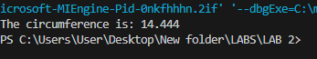
Task 2:
Write and run a program that performs the following steps:
• Create variable f of related data type.
• Assign values to above variables.
• Calculating the equivalent Celsius temperature C using the formula: C = (5/9) (f - 32).
• Displaying the Celsius temperature C.
Solution:
#include <iostream>
using namespace std;
int main(){
float f;
cout<<"Enter temp in ferhenhite: ";
cin>>f; // Taking value from user
float C = (f - 32) * (5.0/9.0);
cout<<"The temp in celcius is :" << C;
return 0;
}

Output:
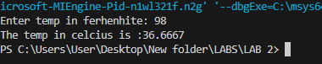

Task 3:
Write a program to take initialVelocity and acceleration from user, save them in respective data types and calculate FINAL VELOCITY as per following formula:
FINAL VELOCITY = initialVelocity + acceleration
Solution:
#include <iostream>
using namespace std;
int main(){
float initialVelocity, acceleration, finalVelocity;
cout<<"Enter initial velocity: ";
cin>>initialVelocity;
cout<<"Enter acceleration: ";
cin>>acceleration;
finalVelocity = initialVelocity + acceleration;
cout<<"The final velocity is: "<< finalVelocity;
return 0;
}

Output:
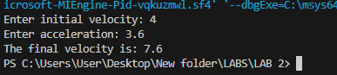

Task 4:
Take distance and time from user, save them in respective data types and calculate SPEED as per following formula:
s𝑝𝑒𝑒𝑑 = 𝑑𝑖𝑠𝑡𝑎𝑛𝑐𝑒 / 𝑡𝑖𝑚e
Solution:
#include <iostream>
using namespace std;
int main(){
float speed, distance, time;
cout<<"Enter Distance (m): ";
cin>>distance;
cout<<"Enter time (s): ";
cin>>time;
speed = distance / time;
cout<<"The speed is: "<< speed;
return 0;
}
Output:
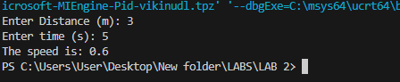

Task 5:
Take mass and velocity from user, save them in respective data types and calculate KINETIC ENERGY as per following formula:
KINETIC ENERGY = 1/2 . 𝑚𝑎𝑠𝑠 .𝑣𝑒𝑙𝑜𝑐𝑖𝑡𝑦2
Solution:
#include <iostream>
using namespace std;
int main(){
float kineticEnergy, mass, velocity;
cout<<"Enter mass (m): ";
cin>>mass;
cout<<"Enter velocity (s): ";
cin>>velocity;
kineticEnergy = (1 * mass * (velocity * velocity)) / 2.0;
cout<<"The Kinetic energy is: "<< kineticEnergy;
return 0;
}
Output:
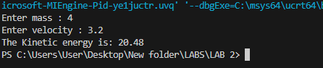

Task 6:
Write a program that will ask UNIT PRICE of chocolate, ice-cream and french-fries. Then your program will ask about (QUANTITY) how many chocolate, ice-cream and french-fries you have to buy. In the end, you have to print the TOTAL BILL by simply multiplying UNIT PRICE of chocolate with QUANTITY of chocolate and so on and so forth.
Solution:
#include <iostream>
using namespace std;
int main(){
int chocolatePrice = 20;
int icecreamPrice = 150;
int frenchFries = 100;
int choc_q , ice_q , fries_q;
cout<<"The price of chocolate is: " << chocolatePrice<<endl;
cout<<"The price of ice cream is: " << icecreamPrice<<endl;
cout<<"The price of french fries is: " << frenchFries<<endl;
cout<<"Enter quantities of items you want: "<<endl;
cout<<"Chocolates: ";
cin>>choc_q;
cout<<"Icecream: ";
cin>>ice_q;
cout<<"French Fries: ";
cin>>fries_q;
int total_bill = (chocolatePrice * choc_q ) + (icecreamPrice * ice_q) + (frenchFries * fries_q);
cout<<"Your Total Bill is: "<< total_bill;
return 0;
}

Output:
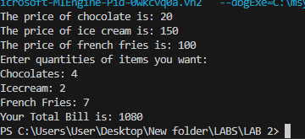

Task 7:
Make a program where it is asked form user to enter total amount, you have to answer how much ZAKAT to be paid on that amount. ZAKAT is the 2.5% of the total amount.
Solution:
#include<iostream>
using namespace std;
int main(){
int totalAmount;
cout<<"Enter your total amount: ";
cin>>totalAmount;
float zakat = (2.5/100) * totalAmount;
cout<<"The Zakat you need to pay is: "<< zakat;
return 0;
}
Output:
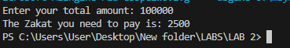

Task 8:
Write and run a program that reads an angle (expressed in degrees) and states in which quadrant the given angle lies. An angle A is said to be in the
• First quadrant if it is in the range 0 <= A < 90
• second quadrant if it is in the range 90 <= A < 180
• third quadrant if it is in the range 180 <= A < 270
• and fourth quadrant if it is in the range 270 <= A < 360
Solution:

#include <iostream>
using namespace std;
int main(){
int angle;

cout<<"Enter angle is degrees: ";
cin>>angle;
if (angle >= 0 && angle < 90){
cout<<"First Quadrant";
}
else if(angle >=90 && angle <180){
cout<<"Second Quadrant";
}
else if(angle >=180 && angle <270){
cout<<"Third Quadrant";
}
else if(angle >=270 && angle <360){
cout<<"Fourth Quadrant";
}
else {
cout<<"You have entered wrong value (>360)";
}
return 0;
}
Output:
